A correct by construction layout placement flow for hierarchical mixed signal designs

Madan Lal
Vijayanand Elumalai
Dilip D

Intel Technology India Pvt. Ltd.
SRR2, Outer Ring Road, Deverabeesanahalli, Bangalore

www.intel.com

ABSTRACT

Winning in fiercely competitive SoC market requires deliverin innovative products in shortest possible time-to-market. One of key design enablers in improving time-to-market is automated and correct-by-construction analog layout placement. Earlier attempts in this field required users to input extremely granular constraints for various devices and specify their relationships. This problem is further exacerbated by numerous possibilities offered by analog layout placement. We will explain as how to quickly generate a number of optimal layouts in face of extremely complex design rules. In this paper, we will also explain challenges associated with hierarchical analog layout placement and how constraints can be applied at any level of hierarchy. With this approach, we were able to generate multiple layouts and create a high quality final layout for any schematic design hierarchy. We will also show as how we reduced overall analog layout time by about 50% using this approach. Specifically, we will also discuss how we fine-tuned the placement engine to handle complex design rules and generate layouts which are routing and metal/base fill friendly.

Table of Contents
1. Introduction 3
2. Correct by construction floor planning architecture 3
3. Layout synthesis using HelixTM: 6
4. Conclusion 9
5. References 10

Table of Figures
Figure 1 the constraint driven analog layout generation flow [1] 3
Figure 2 Correct-by-construction floor planning architecture 4
Figure 3 Conventional method of patterning devices. 4
Figure 4 Device grouping for matching 5
Figure 5 Automated leaf and hierarchical layout generation. 6
Figure 6 General HelixTM block diagram 6
Figure 7 Basic categories of placement rules 7
Figure 8 Solution architecture for correct by construction hierarchical placement 8
Figure 9 enabling process portable analog IPs 9

Table of Tables
No table of figures entries found.

Introduction
The integration of high-performance analog and digital circuits leads to an increasing need of new tools compatible for both digital and analog parts. Unfortunately, low acceptance of CAD tools in analog domain presents a serious bottleneck to fast realization of layout details. First, when it comes to automate analog layout with constraints related to transistor matching schemes, still a strong need for automations is realized in order to boost up the layout productivity. This is still a major reason why design of analog layouts needs skilled engineers and layout design cycle is more cumbersome especially when it comes to sensitive custom analog layouts. Second, the number of design rules at nano technology nodes is so large that few designers have time to fully optimize their layout to all of these rules at once. Instead, to meet the schedule, designers often focus on a few key rules, and simply leave extra area margin.

A formal way of specifying analog layout constraints for a design is essential in a structured layout methodology and is also a requirement for any analog layout automation tool. Figure1 shows a constraint driven analog layout generation flow [1]. Although analog circuit topologies are frequently reused, the parameters of individual devices are usually optimized to maximize performance and to minimize power consumption for a given specification. This means that a significant portion of layout has to be redone even if a circuit topology is reused. Therefore, increasing time-to-market pressure has forced companies to structure their layout flows and to apply automation techniques where-ever possible. In this paper we propose a automated and constraint driven floor-planning and placement solution for hierarchical mixed signal layout designs.
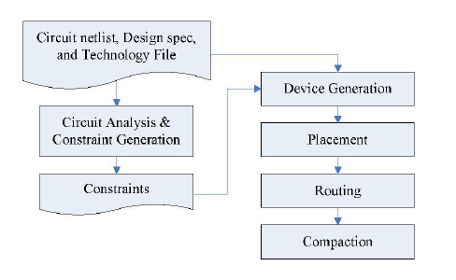
Figure 1 the constraint driven analog layout generation flow [1]

Correct by construction floor planning architecture
Physical design floorplanning is an artwork that transforming components in circuit design into geometric representations of shapes and placing them into a smallest available die size, with sufficient space meeting timing and other design requirements. Physical designers often face lot of challenges in floorplanning due to ever-increasing design rule complexity while trying to meet various circuit performace requirements [1]. Various design rule violations requires rework on physical design, which is time-consuming and causing huge impact on project schedules. Rework on a large and complex design can cost a couple of months of productive time. Therefore, correct-by-construction floorplanning is important to eliminate or reduce the number of iterations in re-design. To overcome this problem, we proposes a constraint-driven layout synthesizer flow which is more flexible and provide mutliple layout options. As shown in figure 2, this methodology includes the expert knowledge in form of layout constraints and a enables layout placement engine which generates various layout placement options for circuit/area optimizations. This has been realized by following simple steps:

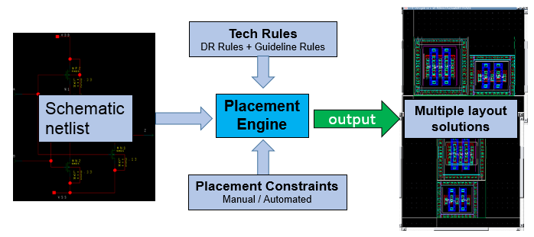
Figure 2 Correct-by-construction floor planning architecture
- Grouping appropriate devices for matching:
Inorder to automate the grouping of the devices from the netlist, we need a constraint generator which can recognize particular device connection and then apply appropriate patterning which can be fed to the placement engine as constraints. The figure 3 shows a conventional method where we apply device noting scheme for device patterning. Figure 4 shows device grouping scheme by the constraint generator for a differential pair circuit. Once we recognize the device groups, the constraint generator will apply appropriate pattern (Interdigitate or common centroid or simple arrays) for these device groups. The constraint generator can be any tool or code which can read in the netlist and identify the matching pairs and apply patterns.

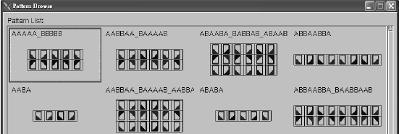
Figure 3 Conventional method of patterning devices.

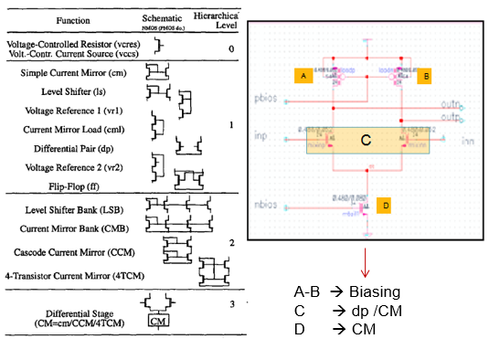
Figure 4 Device grouping for matching

- Placement design rule and guideline constraints:
For analog layout, design constraints are as important as design data.It is difficult to generate credible physical implementations from schematics without user defined physical constraints. It should be compiled and supported by the tool. Some of the basic placement constraints for critical circuits are:
- Alignment & orientation
- Symmetry
- Pair layouts
- Shielding
- Boundary area
- Number of contacts
- Dummies
- Clustering
- And many, many more…
For advanced process nodes, there are many additional placement constraints such as high voltage design rules, routing and DFM friendliness. As shown in figure 5, the proposed correct-by-construction architecture is broken into two domains:
- Automated Leaf Cell Layout Generation.
- Automated Multi-level Layout Generation.

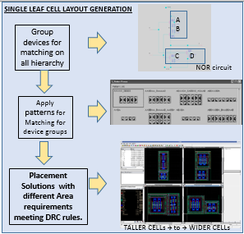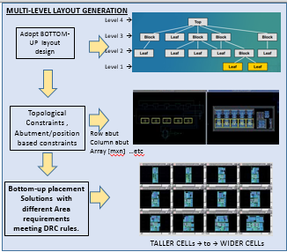
Figure 5 Automated leaf and hierarchical layout generation.

Layout synthesis using HelixTM:
For an analog layout automation tool to deliver production-ready results, it must simultaneously optimize circuit design requirements (matching, symmetry) with device layout requirements (device and contact ring abutment, well merging etc.), while obeying process requirements (design and DFM rules). Previous attempts at analog layout automation failed to gain wide acceptance because they compromised one or more of these three requirements. With HelixTM we were able to achieve all three. HelixTM is fully hierarchical and offers capacity in the tens of thousands of transistors, enabling it to optimize floorplanning and placement for entire custom IC blocks or IP at once. Its output is an industry standard OpenAccess database.

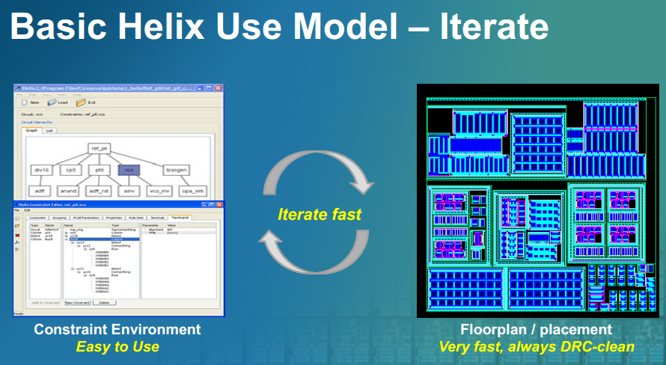
Figure 6 General HelixTM block diagram

Basic design rules and guidelines for HelixTM using Santana.tech file
Device placement algorithm in HelixTM works based on placement rules defined in floor planning technology file (a.k.a Santana.tech). A well-prepared Santana.tech with high quality of placement rules is essential to implement a correct-by-construction floor planning. Placement rules in Santana.tech file are compliance with physical design rules targeted to specific process technology. The Santana.tech file may require further refinement for better layout quality.
As shown in figure 6, there are three categories of placement rules in Santana.tech file:
- Spacing between pattern cells
- Spacing between standard cells,
- Spacing between pattern cells and standard cells.
Placement rules between pattern cells or standard cells are described by a space value between diffusion and nwell. The spacing values vary by devices type, hence increasing total number of placement rules. Refinement of placement complex rules is essential to ensure the quality of floor planning. Layout verification is performed in the quality assurance process to ensure a design rule violation free results.

Figure 7 Basic categories of placement rules

Figure-8 shows overall solution architecture. The lowest level of hierarchy is PyCell which represents basic transistor devices used for device generation. PyCell is written in Python. PatternCell is the next level of hierarchy and represents a composite PyCell, written in Python. PatternCell is used for inter-digitation of groups of transistors, implementing tap rows to meet poly density requirements. The next level of hierarchy is LeafCell which is comprised of PyCells, PatternCells, macros (for passive devices such as resistors, capacitors, diodes etc.), and standard cells as applicable. LeafCell is constructed by HelixTM, adhering to user defined constraints (physical/topological, electrical/net weight). A block is generated by Helix as a combination of LeafCells at the next level of hierarchy, and so on. Helix has ability of automatically varying the row/columns of PyCells/PatternCells, R & C, generating various x-y aspect ratios, through all the hierarchy levels including LeafCells, blocks, etc. The user is then provided with various available options. The HelixTM GUI plots the results from aspect ratio design exploration in two ways:
- Connectivity quality: it is a number representing the average Manhattan route length in the corresponding level of hierarchy. A smaller number indicates a shorter total route length which can indicate a more desirable solution.
- Utilization ratio: it represents a measure of area usage efficiency. A higher number indicates more efficient area usage.

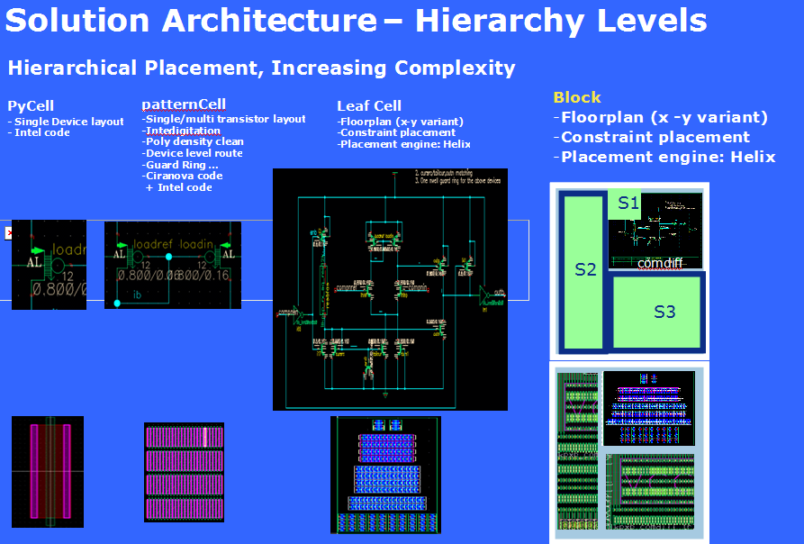
Figure 8 Solution architecture for correct by construction hierarchical placement
The powerful capability of traversing the entire hierarchy though all possible aspect ratios provides the means for floor plan exploration and optimization at various levels. A typical user model would be to start with minimal constraints, refine through an iterative approach and lock down to a desired floor plan once satisfactory. This complicated design topology can be obtained with a very little design time. This layout is far compact in size and follows a cell based analog automation scheme. The automation scheme discussed in this paper can make analog layout design much simpler and the layout design time gets reduced to very major extent and a very high quality design is assured. The below table shows the comparison of the efforts required for some test case designs.
Table 1 Layout effort comparison
Block | No.of hierarchy levels | Manual layout | Layout using Helix based solution
1 | 2 | 0.5 day | 1minute
2 | 1 | 1.5 day | 5minutes
3 | 1 | 0.5 day | 1minute
4 | 1 | 0.5day | 1minute

As can be seen from above table, the manual layout required about 1-2days, whereas this can be achieved in few minutes using HelixTM based solution. We have explored sumptuous methods and implemented few solutions and have seen that automation of analog layout is highly useful to derive high quality layouts with a very small design time. This helps to reduce many layout issues which happens as a result of human errors. The summary of the proposed method is given below:
  - Handle both analog and digital blocks for generating constraints and placements.
  - Compact design (optimum placement).
  - Excellent quality placement.
  - Drastically benefits in terms of productivity and schedule.
By separating design data (netlist and constraints) from process data, HelixTM helps users to create process-portable analog IPs. RuleWise technology handles design rule requirements automatically. As long as we use a process-portable PyCell library and the circuit topology remains the same, the design data can be reused to quickly create new layout on different processes.
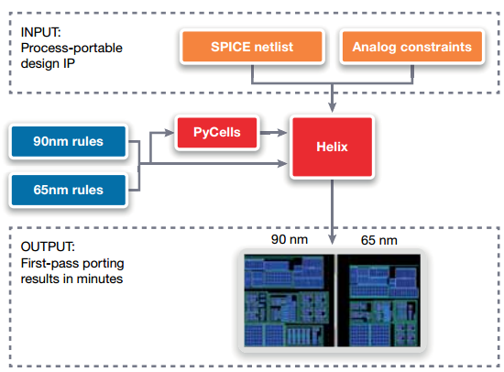
Figure 9 enabling process portable analog IPs

Additional capabilities which were helpful for successful deployment
- The generated ayouts can be futher optimized manually in the PyrosTM
- New constraints can be written back.
- Ability to cross probe bus formated instance names between HelixTM GUI and Pyros.
- Ability to highlight nets visually and configure colors for the highlights.

Area with scope for improvement
- Helix supports only rectangular shapes. The abitlity to work on rectilinear blocks/shapes will help us further optmize the layout area.

Conclusion
A well-defined and integrated set of tools and libraries are needed to produce high-quality analog layouts that meet specifications with minimum resources. Schematic driven layout methods supported by device generator libraries should be a standard part of every analog design flow, since they enhance layout productivity and quality at the same time. Once the constraints are specified, analog cell-level automatic layout tools can generate an optimized layout using cost functions that take analog layout constraints into account. These tools have reached a level of maturity where they can be used successfully in an interactive or fully automated way. Tools that support analog layout migration and reuse offer tremendous opportunity for productivity improvements in analog design flows.

References
- Po-Hung Lintt, Ho-Che Yut, Tian-Hau Tsait, and Shyh-Chang Lin, “A Matching-based Placement and Routing System for Analog Design,” IEEE Symposium on VLSI Design, Automation and Test, VLSI-DAT 2007, pp. 1-4.
- Linfu Xiao and Young E.F.Y “Analog Placement with Common Centroid and 1-D Symmetry Constraints,” IEEE Design Automation Conference, 2009, pp. 353-360.
- Nassaj A, Lienig J, and Jerke G, “A New Methodology for Constraint-Driven Layout Design of Analog Circuits,” IEEE International Conference on Electronics, Circuits, and Systems, 2009, pp. 996-999.
- Synopsys Incorporation “Helix User Guide, Version I-2013-13”, December 2013
- Synopsys Incorporation “SantanaTM Technology File Reference Manual, Version 2013-06”, June 2013

